Project Design Phase
Problem – Solution Fit Template

Date | 18 June 2026
Team ID
Project Name | ShopEZ-E-commerce-Application
Maximum Marks | 2 Marks

Problem – Solution Fit Template:
1. Customer Segment (CS)
- University students and beginner investors.
- Individuals looking to learn about the stock market without financial risk.
2. Jobs-to-be-done / Problems (J&P)
- Need a safe, realistic environment to practice buying and selling stocks.
- Need to understand market dynamics and track a simulated portfolio using live market data.
3. Triggers (TR)
- Hearing peers or friends talk about stock market profits.
- Reading financial news or watching finance influencers and wanting to participate.
4. Emotions: Before / After (EM)
- Before: Anxious, intimidated by complex charts, scared of losing real money.
- After: Confident, financially literate, empowered to make real investments later.
5. Available Solutions (AS)
- Traditional brokerages (require real money deposits and are intimidating).
- Basic stock market mobile games (often lack real-time data or professional UI).
- Reading books / watching YouTube (provides theory, but no hands-on practice).
6. Customer Constraints (CC)
- Limited disposable income or capital to risk on real trades.
- Lack of deep financial literacy.
- Fear of making costly mistakes in the real market.
7. Behaviour (BE)
- Downloading real trading apps but abandoning them at the "deposit funds" screen.
- Seeking advice on online forums (like Reddit) or asking friends for stock picks.
8. Channels of Behaviour (CH)
- Online: YouTube finance channels, Reddit (e.g., r/investing), Discord servers, University group chats.
- Offline: Campus finance clubs, casual discussions with friends.
9. Problem Root Cause (RC)
- Financial markets inherently involve real monetary risk.
- Professional trading tools are built for experienced experts, lacking onboarding features for complete beginners.
10. Your Solution (SL)
- A MERN-stack simulated stock trading platform (ShopEZ) that provides users with a virtual wallet.
- Features real-time API market data and risk-free portfolio tracking to bridge the gap between theory and actual trading.
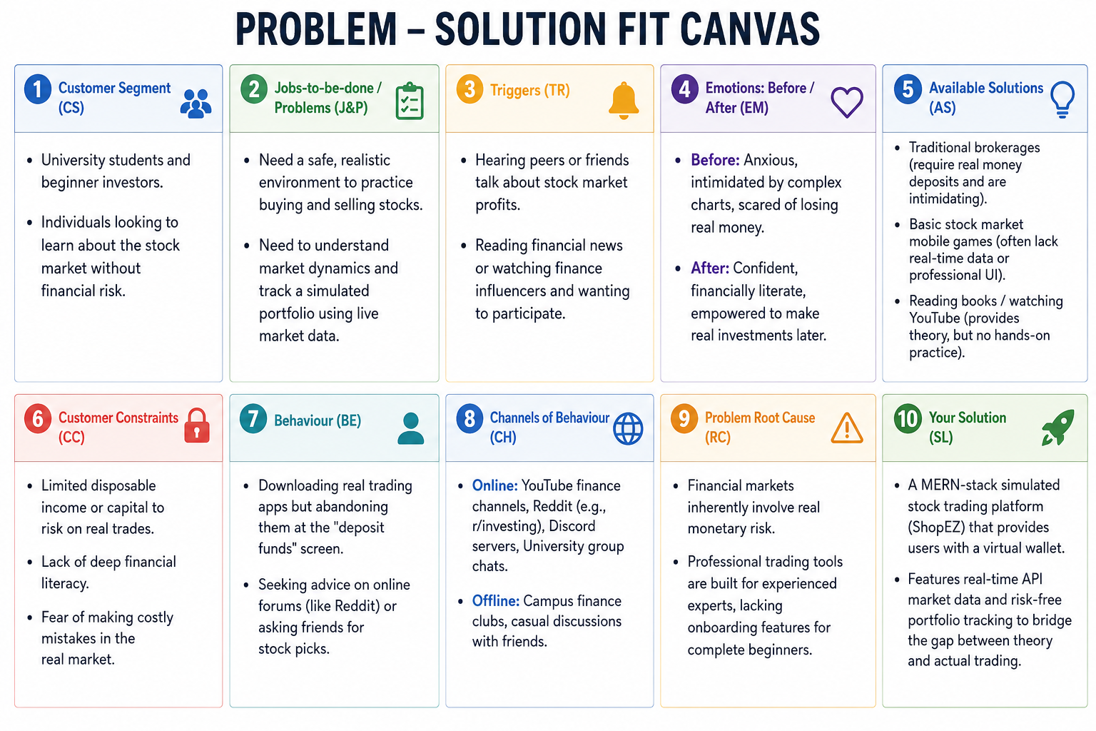
References:
- https://www.ideahackers.network/problem-solution-fit-canvas/
- https://medium.com/@epicantus/problem-solution-fit-canvas-aa3dd59cb4fe

